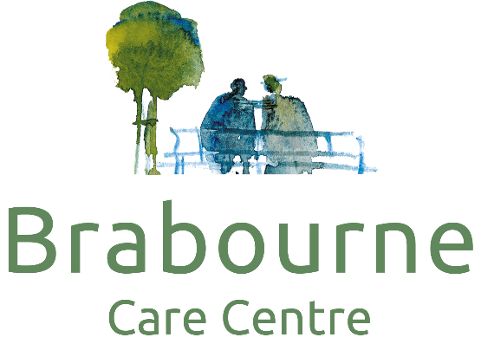

Reception Admin Assistant
Job details
Salary
£16,848 - £16,979 a year
Full-time
Part-time
Permanent
Job Description
Reporting to the General Manager and Senior Management Team and Group Administrator, the Receptionist / Administrator will work as part of a administration team that are responsible for all the administrative duties within the home.
The Receptionist / Administrator will assist in ensuring the smooth and efficient management of the administrative duties within the home, ensuring that customer service is provided to the highest standards.
Ensure that the overall administration is delivered at a high standard
Work effectively as part of a team.
Ensure that telephone calls and enquiries to the Home are handled both professionally and promptly.
Ensure that all records for the team are accurate and maintained this includes annual leave and sickness
Attend all training as required and be responsible for own personal development
Ensure all new employee information is compliant and has required, references, DBS and other paperwork prior to commencement and all is recorded correctly
Maintain records of all orders and invoices submitted for reconciliation and payment to Finance to allow prompt and accurate responses to enquiries
Ensure that all information of confidential nature is not divulged to third parties
To actively engage with residents in conversation and meaningful occupation related to their lifestyle choices at a level and pace that values the individual and respects their dignity and communication differences.
Due to regulatory requirements candidates will be required to be fully vaccinated for COVID-19.
Job Types: Full-time, Part-time, Permanent
Part-time hours: 18 - 36 per week
Salary: £16,848.00-£16,979.04 per year
Schedule:
Day shift
COVID-19 considerations:
Care Home Setting
Infection Control Measures in place
Experience: Administrative Assistants & Receptionists: 1 year (required)

